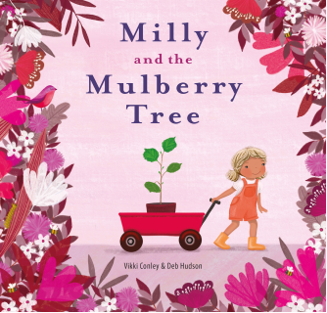

Title: Milly and the Mulberry Tree

Author: Vikki Conley
Illustrator: Deb Hudson
Publisher: EK Books
Price: $24.99
ISBN: 9781922539120
Publication date: June 2022
Audience age: 4 – 8 years
Key Curriculum Areas: English, Mathematics, Science, Humanities and Social Sciences, Health and Physical Education, Visual Arts

SYNOPSIS:
A delightful story about the magic of both home and other worlds, which will encourage exploration, caring for the environment, and seeing the wonder in everywhere we go.
When Milly and Papa plant a mulberry tree, Milly has no idea how magical and inspiring the tree will become. From nurturing silkworms to making magic potion mulberry ice cream, the mulberry tree becomes the centre around which Milly’s life turns. Then, Milly grows older, and finds herself travelling to new and exciting places. She discovers the fabric her silkworms created, and builds a life in a beautiful, faraway land. But she never forgets the magic of the mulberry tree, and always longs to return…

Milly and the Mulberry Tree is a story about growing up, family and home. Full of colourful, whimsical illustrations, it explores our ties with nature and places in a way that will resonate with any young readers who likes playing outdoors, or have their own special hideaway. It also holds an inspirational message about the importance of exploring new worlds as we grow, while keeping home close to our hearts.

Inspired by the 100-year-old mulberry tree that grows in the author’s own childhood garden, this is a book full of heart and joy that will be a delight for families to share.

THEMES:
- Exploration / wonder
- Caring for the environment
- Celebration
- Family / Cross-cultural family connections
- Home
- Growing up
- Animal habitat/insect life-cycles
- Expressing and developing ideas

SELLING POINTS:
- A uniquely heartfelt story inspired by the author’s own childhood that will resonate with anyone for whom home has a special place in their heart.
- Centres around the mulberry tree, which has global significance as a common feature of gardens in Australia with a heritage stemming from Asia and North America.
- Features the life-cycle of silkworms, which is often a classroom activity for preschools and primary schools.
- Gorgeous illustrations reflect the vibrance of the nature surrounding Milly and the wonder and cultures of the new worlds (Asia) she travels to.
- Educators will love the engaging narrative of this story with good use of figurative language and teachable moments around environment, celebration and cross-cultural family connections.

WRITING STYLE:
Milly and The Mulberry Tree is a lyrical, heart-felt narrative written in prose, with frequent use of figurative language. Metaphors, alliterations and similes are used together with descriptive verbs and adjectives to communicate the strong connection that Milly (and the author) has with nature, place and home.

It is a sweet text full of wonder that has been inspired by the author’s childhood memories. It is a good example of how writing about personal experiences can result in authentic and evocative narratives. Vikki often encourages students to use their memories to inspire their writing.

It is a relatable and accessible text (for children, parents and teachers) that will stimulate conversations about home, place, growth, habitat and creativity. The story’s themes can be explored on a variety of levels appropriate for pre-schoolers up to middle primary students.

ILLUSTRATION STYLE:

AUTHOR MOTIVATION:
Much of this story has been inspired by my childhood. Milly and the Mulberry Tree has been written to celebrate the 100-year-old mulberry tree that grows in the centre of my childhood garden, always fruiting just in time for Christmas and the keeper of four generations of memories.
I have so many fond memories of playing and eating from our mulberry tree. My children now also share the same nostalgic feelings as I do with relation to the tree. It has always, in my mind, been my Faraway Tree – a magic place for adventure, creativity and deliciousness!
Our mulberry tree was always the centre of everything, we:

- Hung hammocks, swings, horse saddles from its branches to swing and play
- Climbed and explored its long winding branches
- Picked mulberries every year around Christmas and January/summer time
- We picked buckets of them, squashed them in our hands, had stained hands and feet from their vivid purple colour
- We ate them with ice-cream, yogurt, other fruit from our orchard, straight from the tree
- We made mulberry jam from them
- We celebrated many birthdays with parties under its giant umbrella, with lanterns hanging from its branches!
- I experienced silkworms with my children at their kindergarden, which also grew a mulberry tree

Also, I draw so much creative inspiration from the natural world. Art and science too has so many connections to nature in many ways and I thought a book about how nature inspires us all would be interesting.
The connection that we all have to our roots, our home, the things that connect and return us to our family and heritage, is also something I wanted to explore.
Like Milly, I too skipped one significant celebration (Christmas) away from my family (while travelling through Europe) and missed the traditions of our home terribly! But I was inspired and touched by the new cultures that I explored.

AUTHOR & ILLUSTRATOR BACKGROUND:

Vikki Conley is a CBCA notable author with eight internationally published picture books. She writes children’s stories that celebrate the spirit of wonder, adventure and freedom that she wishes every child could enjoy.

Vikki has worked as a professional writer, photographer and marketer, with diverse communities across three continents, for over 20 years.

She is a nature lover, intrepid traveler and passionate climber of a 100-year-old mulberry tree that still grows at her childhood home.

Deb Hudson is an illustrator who is passionate about drawing bright, happy and colourful images that evoke emotion and thought in their viewer. Her books include The Golden Thread and Pear of Hope.

INTERVIEW:
AUTHOR
What is the inspiration for this story?
The adventures that I had as a children in the 100 year old mulberry tree that grew right in the middle of our main garden. Nature has always been at the centre of my life. We had many pets growing up on the farm where I lived, we regularly camped and hiked in the Australian wilderness spotting insects, butterflies, orchids and small creatures.

One of my first pets were Monarch butterflies, which we attracted by planting swan bushes in our garden. We pinned the chrysalis(cocoons) to our dining room window ledge and watched the metamorphosis (transformation) into the butterflies. We’d watch them hatch and then would immediately release the butterflies.
My father also collected butterfly and moth specimens, which we loved looking at – all colourful and powdery soft - in their special wooden boxes.

I have also travelled to many places across Asia and have fallen in love with the lanterns, food and cultures in many of these countries.

What was the most rewarding part of this project?
Seeing Deb transform my words into the beautiful, vivid illustrations that gave the story wings to fly.

What was the most challenging part of this project?
Nothing! I think we (author, illustrator, publisher) all become totally obsessed and passionate about mulberry trees, silk fabrics and Milly’s story. It has been an absolutely joy to collaborate with creative minds who share similar passions.

ILLUSTRATOR
What media do you use to create your illustrations? Briefly describe your process.

What was the most rewarding part of this project?

What was the most challenging part of this project?

TEACHER ACTIVITIES/NOTES:

Discussion Notes and Activities:
N.B. These questions and activities can be adapted to suit the experience and ability of students.

Discussion:
Before Reading –
Ask students if they have heard of a mulberry tree before. What are mulberries? Do you know that silkworms inhabit these trees? What do you know about silkworms?
Teach students the song, ‘Here We Go Round the Mulberry Bush’? Sing it together.
Look at the cover of Milly and the Mulberry Tree. What do you see? What does it make you wonder about? How does the cover make you feel?
What do you think the story might be about? What might be the themes or main idea of the story?
Have you ever planted your own tree? Did you watch it grow? How is tree planting good for nature? How can we best look after nature?

During Reading –
What might Papa mean when he says the tree ‘will always keep us together.’?
Have you heard of ‘Pop Goes the Weasel’? It’s another nursery rhyme / song with the same tune as ‘Here We Go Round the Mulberry Bush’.
What do you notice in the pictures of the silkworms and moths?
Have you ever tried mulberries?
What do you notice about Milly and the mulberry tree? How are they changing?
Do you think Milly will return home?
What do you think Milly is making with the silk material?

After Reading –
What was the story about? What is the main idea?
What did you like / dislike about the story? How did it make you feel?
What did you learn about Milly? What did you learn about mulberry trees?
What can you tell about Milly’s family? How did the story show family diversity?
How did the mulberry tree help keep the family together? How did it stay with Milly even after she grew up and moved to new places? What did she do preserve her memory of the precious cocoons and mulberry leaves?
What kinds of activities did Milly and her friends and family do with and around the mulberry tree?
What did you learn about silkworms? Can you describe the lifecycle? Where do you think the name ‘silkworm’ comes from? What is their special role? How did Milly continue to use the silkworms as she became an adult? Why is the role of silkworms important?
In what ways were the mulberries ‘magical’? Can you think of more ways to use mulberries?
How do the illustrations give clues as to the new place Milly has moved to? How do you think she feels being away from her family? What do you think she likes about her new home?
What does grown-up Milly use the silky fabrics for? In what other ways does she still use and remember all the wonders of the mulberry tree?
What do you like about the illustrations? How do they represent the growth, emotions, and diversity of the characters (including the tree) in the story? How has colour, pattern and texture been used to show certain symbolic and visual details?
What are the most important messages within this story?

Activities:

English

Mulberry Tree Nouns, Verbs and Adjectives
(ACELA1437) (ACELA1452) (ACELA1454) (ACELA1468)
Investigate the verbs (action words) and adjectives (describing words) used in Milly and the Mulberry Tree to describe the tree, its creatures and their features. Write the nouns, verbs and adjectives in different colours for various lines in the book. For example:
‘Milly sang to the caterpillars as they nibbled on tender mulberry leaves.’
‘When the silkworms weaved themselves inside their silky cocoons, Milly waited and waited and waited…’
‘The moths fanned their wings until they dried powdery soft.’
‘The berries tingled inside her cheeks like sour-sugary jubes.’

Adjectives: Character Profiles
(ACELT1783) (ACELT1589) (ACELY1650) (ACELY1660) (ACELA1452) (ACELA1468) (ACELA1469)
Write adjectives, or describing words, and other information that describes either (or both) Milly and the mulberry tree. Use the character profile sheets (see BLM 1 and 2) to list the features including appearance, behaviours, character traits, feelings, changes, etc.

Metaphors / Figurative Language
(ACELA1460) (ACELA1435) (ACELA1786) (ACELA1437) (ACELA1451) (ACELA1454) (ACELA1469) (ACELA1470) (ACELT1783) (ACELT1582) (ACELT1591) (ACELT1832) (ACELY1650) (ACELY1660) (ACELY1670)
Metaphors are used with figurative language throughout the book as symbolic representations of nature, growth and feelings. Explore and discuss how the following phrases metaphorically refer to both Milly and the tree. What are the literal and underlying meanings?
‘When the mulberry tree’s limbs stretched out to the world, so did Milly’s.’
‘Both forming elegant shapes … … and dancing under a silvery sky.’
‘Every year, the mulberry tree wore its apple-green gown, studded with berry sequins.’
Students can write their own sentences using figurative language / metaphors about a growing / dancing / sequin-studded tree. Illustrate.

Comprehension: Text-to-Self, Text-to-Text, Text-to-World
(ACELT1575) (ACELT1783) (ACELT1582) (ACELT1584) (ACELT1589) (ACELT1590) (ACELY1650) (ACELY1660) (ACELY1665) (ACELY1670)
Ask students to think about the text and how this connects to what they know. Answer and write about the following questions…
Text-to-Self: What are some aspects in the story, Milly and the Mulberry Tree, that you can relate to in your own life? Has there been a time that you planted and/or played around a tree? When was a time that you made something from berries? Celebrated a party in the garden? Missed a yearly event for the first time? Moved away from home? How is your family diverse? Have you followed a passion for many years?
Text-to-Text: Compare aspects of the story to those in another similar text, such as a different story about a precious tree, or life cycles in nature, or about family connections / cross-generations and cultures, or about moving to new places.
Text-to-World: What can you do to care for nature and the environment? What can you find out about the silk industry, or cultures, traditions and celebrations different to your own? How many uses for mulberries / mulberry leaves can you find? How can this story help other children across the world?

Nursery Rhyme Comprehension
(ACELA1430) (ACELA1447) (ACELA1463) (ACELA1439) (ACELT1783) (ACELT1582) (ACELT1785) (ACELT1591) (ACELY1655) (ACELY1665) (ACELY1650) (ACELY1660) (ACELY1670)
Read the lyrics to the popular children’s nursery rhyme songs, ‘Here We Go Round the Mulberry Bush’ and ‘Pop Goes the Weasel’. Answer some comprehension questions, such as:
Literal – What are the actions? Who are the characters? Where are they doing the dancing / chasing?
Inferential – What does the song tell us about time and place? Why are these actions done at this time of day? Why might the characters think it’s fun?
Evaluative – What might happen next? Have the characters successfully achieved their goal? Could there be a hidden meaning to the song?

Creative Writing: Nursery Rhyme Poems
(ACELA1430) (ACELA1447) (ACELA1448) (ACELA1463) (ACELA1439) (ACELA1459) (ACELA1474) (ACELT1579) (ACELT1585) (ACELT1592) (ACELT1586) (ACELT1832) (ACELT1833) (ACELY1655) (ACELY1651) (ACELY1661) (ACELY1671)
With reference to the nursery rhyme song from above - ‘Here We Go Round the Mulberry Bush’ – students write their own five-line poem with the same rhythm. Students can write the poem about getting ready or another favourite activity. Students can be extended to write a whole song with several stanzas.
First line: Here we go ‘round the mulberry bush OR This is the way we comb our hair
Second line: The mulberry bush OR Comb our hair
Third line: The mulberry bush OR Comb our hair (Repeat of second line)
Fourth line: Here we go ‘round the mulberry bush OR This is the way we comb our hair (Repeat of first line)
Fifth line: On a cold and frosty morning.

Narrative Writing
(ACELT1580) (ACELY1651) (ACELY1652 ) (ACELT1832) (ACELY1661) (ACELY1672) (ACELY1648) (ACELY1658)(ACELY1674)
Students can write a narrative story based around the wonders they might find under / in the large mulberry tree. What kind of adventures might it take them on, traveling to new places (real or imagined)? What kinds of creatures or characters might be found (silkworms, moths or other insects, or imaginary)? What personal emotional or physical challenges might need to be overcome (eg. missing home, getting stuck in another place)? How will they be resolved?
Begin your narrative with a sizzling start, such as dialogue, onomatopoeia, action or scene setting. Remember to use interesting figurative language!
Set it out with a beginning, middle and end.

Information Report
(ACELA1430) (ACELA1786) (ACELA1447) (ACELA1450) (ACELA1453) (ACELA1463) (ACELY1648)(ACELY1651) (ACELY1658)(ACELY1660)(ACELY1661)(ACELY1668) (ACELY1671)
Science Links: (ACSSU002) (ACSSU017) (ACSSU030) (ACSIS233) (ACSIS027) (ACSIS040)
Students can create a poster or digital presentation with the collation of facts about the mulberry tree, or the life cycle of the silkworm. Be sure to include a title, interesting facts, diagrams or pictures, and captions for the information report. See BLM 3 for a life cycle template.

Family Tree / Family History Interviews
(ACELA1426) (ACELA1443) (ACELA1460) (ACELA1428) (ACELA1444) (ACELA1446) (ACELA1461) (ACELA1437) (ACELA1454) (ACELY1646) (ACELY1784) (ACELY1656) (ACELY1788) (ACELY1666) (ACELY1789)
Humanities and Social Sciences Links: (ACHASSI001) (ACHASSI018) (ACHASSI002) (ACHASSI035) (ACHASSI020) (ACHASSI009) (ACHASSI025) (ACHASSI041) (ACHASSI027) (ACHASSK011) (ACHASSK012) (ACHASSK013) (ACHASSK028) (ACHASSK029) (ACHASSK030) (ACHASSK044) (ACHASSK045) (ACHASSK046)
Students can practise interaction and communication skills through some research into their own family history by interviewing an older family member, and representing their ancestry on a simple family tree. Some interview questions or topics may include: Who is in my family? What are the names of my grandparents on my mother’s side? Father’s side? Where and when was my mother born? Father born? Grandparents born? What is their happiest childhood memory? Jobs and careers? How did they meet their partner? What is a favourite family tradition?
Students then complete a family tree including their immediate (and extended) family members. See BLM 4 for an example of a family tree template, or below.
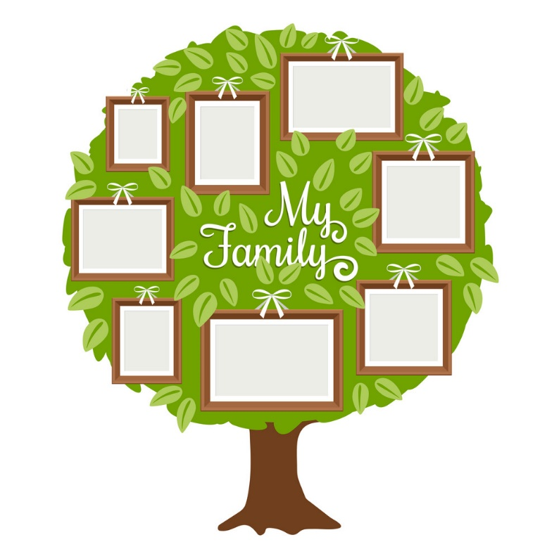

Thinking Tools / Graphic Organisers
(ACELA1429) (ACELT1575)(ACELT1783) (ACELT1583) (ACELT1589) (ACELY1650) (ACELY1660) (ACELY1670)
X-Chart: Students can imagine themselves as Milly in one of the scenarios in the book, such as playing with silkworms and cocoons, or making use of the mulberries, or as a grown up in a new place. Complete the graphic organiser with the headings: Looks Like, Sounds Like, Feels Like, Smells/Tastes Like. See BLM 5.
Tree Diagram Mind Map: Use the tree diagram to flesh out ideas on a chosen topic, such as ‘Planning a Garden Party’. The sub-headings could include, ‘food’, ‘decorations’, ‘games’, ‘guests’, ‘activities’, ‘party bags’, ‘cake’, etc, with the descriptions providing further detail in the outer leaves. See BLM 6.
Venn Diagram: Complete a Venn Diagram to compare the similarities and differences between Milly and the mulberry tree. Think about their appearances, personality traits, interests, growth / changes, special features, etc. Alternatively, compare Milly as her younger and older self. See BLM 7.

Mathematics

Timelines
Measurement: (ACMMG007) (ACMMG021) (ACMMG041)
Milly (and the mulberry tree and silkworms) changes and grows over time. Students can complete a timeline of any of these, or their own life, to show the chronological ages from birth to now, including description of major events. Include any pictures and diagrams for each year / stage. This could be presented digitally, as a poster or in a scrapbook.

Humanities and Social Sciences

Celebrations and Traditions
(ACHASSI001) (ACHASSI018) (ACHASSI002) (ACHASSI004) (ACHASSI019) (ACHASSI036) (ACHASSI037) (ACHASSI005) (ACHASSI006) (ACHASSI039) (ACHASSI008) (ACHASSI026) (ACHASSI010) (ACHASSI043) (ACHASSK011) (ACHASSK012) (ACHASSK013) (ACHASSK029) (ACHASSK030) (ACHASSK046)
Students investigate how they, their family and community, celebrate and commemorate past and present events that are important to them. Activities and topics to explore can include:
- Different kinds of celebrations – why do we celebrate?
- What are traditions? Choose a celebration and write and draw about the traditions that occur for the event.
- Write about a special or unique tradition that your family celebrates.
- Watch videos and read about different cultures, traditions and their celebrations.
- Look at photos of past family celebrations – what are the similarities and differences between then and now?
- Write and draw about your favourite things about a celebration.
- Plan a celebration! What items and resources will you need? Write the steps of what needs to be done.

Science

Silkworm Life Cycle
(ACSSU002) (ACSSU017) (ACSSU211) (ACSSU030) (ACSHE013) (ACSHE021) (ACSHE022) (ACSHE035) (ACSIS014) (ACSIS037) (ACSIS011) (ACSIS024) (ACSIS039)(ACSIS233) (ACSIS027) (ACSIS041) (ACSIS012) (ACSIS029)
(See ‘Information Report’ Task). Other tasks can include, depending on the level of students’ knowledge:
- Match the word of the cycle to the picture (egg, larva, cocoon / pupa, moth). See BLM 8.
- Place the labelled life cycle in order (either in sequential order or as a cyclic diagram).
- Write information about each of the stages in the life cycle.
- Label the parts of a silkworm.
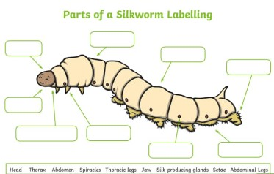

- Create a paper wheel with a split pin to demonstrate the changing stages of the silkworm’s life cycle.
- Create a 3D life cycle model using paper, cardboard, craft foam, wire, cotton wool, and so on.
- Find a mulberry tree and look for silkworms and other insects that live there. Students write and draw what they notice.
- Watch videos about the history of silkworms, facts and how silkworms produce silk. Some facts can be seen here:
Silkworms are awesome! - YouTube
Silk and Silkworm | Fibre to Fabics | Don't Memorise - YouTube

Mulberry Tree Life Cycle / Planting
(ACSSU002) (ACSSU017) (ACSSU211) (ACSSU030) (ACSHE013) (ACSHE021) (ACSHE034) (ACSIS014) (ACSIS024) (ACSIS011) (ACSIS025) (ACSIS039) (ACSIS233) (ACSIS012) (ACSIS027) (ACSIS041) (ACSIS029)
Research and write / draw about the life cycle of the mulberry tree – from seed to sapling to fully grown and flowering fruits. Find out about seed formation and the characteristics of the fruits. See BLM 3.
Students could plant a mulberry tree as a group for future generations to enjoy.

Mulberry Juice Recipes
(ACSSU003) (ACSSU018) (ACSSU031) (ACSHE013) (ACSHE021) (ACSHE022) (ACSHE035) (ACSIS014) (ACSIS037) (ACSIS011) (ACSIS024) (ACSIS039)(ACSIS233) (ACSIS027) (ACSIS041) (ACSIS012) (ACSIS029)
Mulberries are an interesting ingredient for making tasty recipes, and through cooking, students will gain science skills in a hands-on way. For example, they will learn about turning solids into liquids, different textures and the effects of combining different compounds with / without heat or cold. Students can use skills in predicting, observing, recording, evaluating and communicating when working through the processes. Some ideas that include using mulberry juice / leaves include:
- Mulberry jam
- Mulberry ice cream
- Mulberry smoothie
- Mulberry cake / tart
- Mulberry leaf tea
- Mulberry playdough (edible or non-edible). A recipe can be found here: Making Natural Berry Dye + Homemade Mulberry Playdough (childhood101.com)

Health and Physical Education

Healthy Mind / Healthy Body Ideas:
(ACPPS003) (ACPPS004) (ACPPS005) (ACPPS006 ) (ACPPS017) (ACPPS018) (ACPPS020) (ACPPS021) (ACPMP008) (ACPMP012) (ACPMP025) (ACPMP028)
Mindfulness and physical activity are ideal for mental and physical health, as well as building relationships with family and friends.
- Write down, draw or collect your happy moments – create a scrapbook
- Plant a tree or flowers with your family
- Read a book, draw a picture, have a snack or swing in your treehouse, branch or secret spot
- Spend time outdoors and in nature – look for worms and insects, or feed fish in a pond!
- Go berry picking!
- Make different desserts and drinks with your favourite fruits
- Make pictures with natural dyes like mulberry juice
- Role play acting like different creatures – silkworms or moths
- Play and dance while singing nursery rhymes, like ‘Here We Go Round the Mulberry Bush’
- Invite your friends and family to a garden party
- Dress up in your favourite costumes
- Learn about and try dishes / traditions from other cultures
- Create a design and make a piece of clothing with your favourite materials

Visual Arts

Mulberry Juice Painting
(ACAVAM106) (ACAVAM107) (ACAVAM108)
Boil up a small amount of water and mulberries, then strain, to create your own mulberry dye. Students can create a watercolour painting of a silkworm moth or a large mulberry leaf using the mulberry dye. Experiment with different strengths of the maroon colour by adding more or less water for varying hues. Complete with pencil or fine line markers to add details, like the veins in the moth’s wings or mulberry leaf.

Silk Art Creations
(ACAVAM106) (ACAVAM107) (ACAVAM108) (ACAVAR109)
Look at and discuss artworks / patterns on silk created by different artists. Using a piece of plain (white) silk fabric, dilute acrylic paints with water and create a beautiful silk design. Your art could be an item of clothing, such as a scarf, or a piece that could be framed. Students might like to follow the themes in the book, including silkworms, moths, goldfish, berries, etc, for their designs, or something cultural, or a more abstract piece.
Note: Be sure to line your work surface with a drop sheet under your silk art. Once the paint has dried, soak in warm water and fabric softener. You can also iron the piece to smooth and set the paint colour.

Papier-Mache Cocoon
(ACAVAM107) (ACAVAM108)
Blow up a water balloon, tie and cover with papier-mâché mixture (50/50 water and glue, newspaper strips, tissue paper strips, string, and brushes). Add a second layer for strength. Students might like to paint their cocoons once dry. Pop the balloon and pull it out. Hang up the cocoons with string. *Optional: make a paper moth to fit inside the cocoon.

